Thomas Tran
SNHU CS-330: Comp Graphic and Visualization
Professor Ronal Bishop
Module 7-1: Final Project – Design Decision
October 25, 2026
Design Decision
Development Choices
For my final project, I created a 3D study desk scene based on my reference picture. The four basic shapes I used were a plane for the wooden desk, boxes for the laptop, book, and notebook, cylinders for the coffee mug and pen body, and a cone for the pen tip. These shapes were easy to resize, rotate, and move. The coffee mug was very big in the beginning, so it was scaled down and matched with the rest of the items. I also combined multiple shapes to create the laptop and pen.
The objects were arranged to match my reference picture, with the laptop in the center, the book on the left, and the coffee mug and notebook on the right. I used scaling, rotation, and translation to adjust their sizes and positions. For example, I made the coffee mug smaller to match the other objects. The book was moved to the left, the coffee mug to the right, the laptop was placed in the central. I added wood, orange-patterned, and purple stained-glass textures to make the objects look more realistic and easier to recognize.
I added two lights using ambient, diffuse, and specular lighting and make the background have a lighter color to create the lighting effect. One challenge was that some objects appeared too dark. I tested different light positions and material settings to improve their appearance. I kept lighting off for the desk because it caused rendering problems, while the other objects still used lighting. This helped me understand how lighting affects 3D objects.
Camera Navigation
I used the Camera and ViewManager classes from previous milestones to let users explore the scene. The W and S keys move forward and backward, A and D move left and right, and Q and E move up and down. The mouse changes the direction of view, while the scroll wheel adjusts movement speed. Pressing Escape closes the program.
Two viewing modes, Perspective and Orthographic were added to the scene. Pressing P switches to perspective view, where distant objects look smaller. Pressing O switches to orthographic view, where objects do not change size based on distance. Both modes use the same camera position and direction. I adjusted the camera height and angle to make the desk and objects easier to see.
Functions and Code Organization
I used separate functions to keep my code simple and organized. PrepareScene() loads the shapes and textures. DefineObjectMaterials() sets the material properties, and SetupSceneLights() sets up the two lights. RenderScene() draws the objects, while SetTransformations() changes their sizes, rotations, and positions.
These functions helped me reuse code instead of writing everything again. For example, I used the same box shape to create the laptop, book, and notebook. Separating the code into functions also made it easier to find and fix problems. I can reuse these functions in future OpenGL projects.
Reference Image:
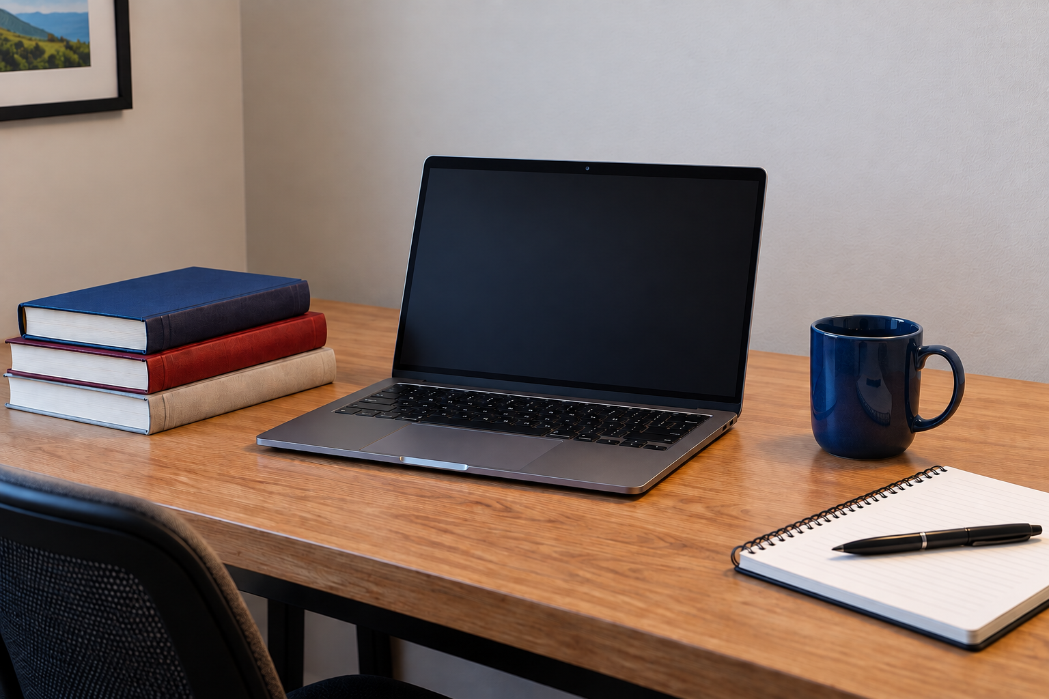

AI Acknowledgment
I used ChatGPT by OpenAI to help understand OpenGL concepts, plan objects, review code, and troubleshoot camera, texture, and lighting problems. I reviewed and modified the suggestions and tested the results in Visual Studio 2022.

